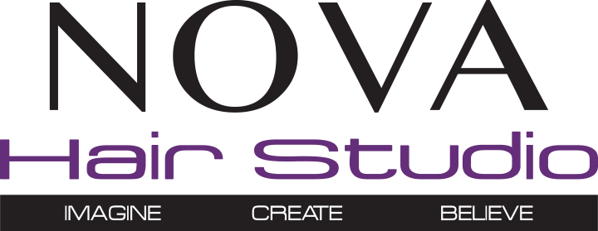

Minor Consent Form for Chemical Services

I, _________________________, am the parent/guardian of _______________________
I hereby give consent for my minor child to receive color/chemical treatments from the
Hair Stylists at NOVA Hair Studio. I understand that I am financially responsible for
the minor and that I must schedule all appointments on their behalf. I grant permission
that my child may receive services with or without my presence.

Signature:_____________________________ Date:_____________________

